ML Project Emily Chen

Note: // are my comments

1.To compute the product of all integer between m and n.

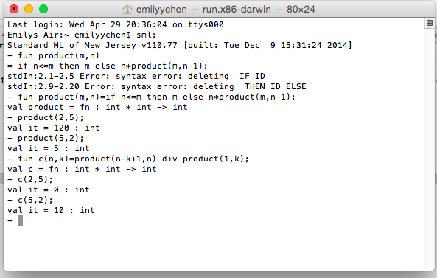

\*\*code:

-fun product(m,n)

=if n<=m then m else n\*product(m,n-1); //my range is between m and n, so if n<=m, then set to return m.

-product(2,5);

//n\*product(m,n-1), here m is 2 and n is 5.

First step = 5\*product (2,4)

= 4\*product (2,3)

= 3\*product (2,2) <- when n<=m, so return m, which is 2.

= 3\*2

=4\*3\*2

=5\*4\*3\*2

=120

val it =120 : int

-product(5,2); //when n<=m, return m.

val it =5: int

2.(list function)

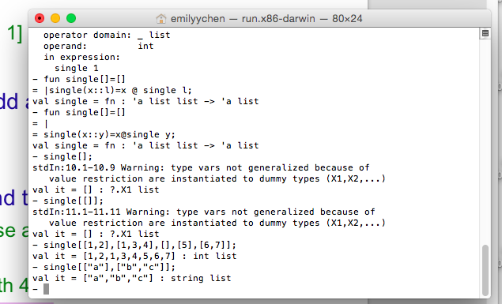

\*\*code:

- fun single[]=[] // let []=[]

= | single(x::y)=x@single y; // use @ to append two lists x and y together

val single = fn : 'a list list -> 'a list

- single[];//first condition, [ ]=[ ], (is like “null”)

stdIn:10.1-10.9 Warning: type vars not generalized because of

value restriction are instantiated to dummy types (X1,X2,...)

val it = [] : ?.X1 list

- single[[]];//the inner [ ] is the element in outside [ ], so will return element “[ ]”.

stdIn:11.1-11.11 Warning: type vars not generalized because of

value restriction are instantiated to dummy types (X1,X2,...)

val it = [] : ?.X1 list

- single[[1,2],[1,3,4],[],[5],[6,7]];// combine list [1,2] and list [1,3,4] and [] and [5] and [6,7]

val it = [1,2,1,3,4,5,6,7] : int list

- single[["a"],["b","c"]];// combine list [“a”] and list [“b”,”c”]

val it = ["a","b","c"] : string list